# Docker Exercise

1. Playing with busy box:
   1. Pull busy box image from the docker hub.

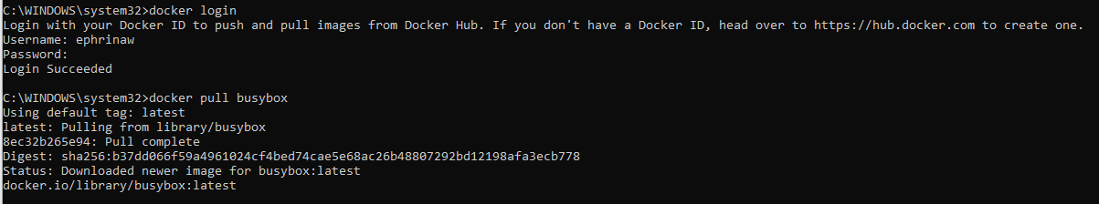

* 1. Display list of all images on your system. Make sure that you have busy box as well. Write the image id for the buysbox image.

Image ID 42b97d3c2ae9

* 1. Run a docker container based on the busybox image
     1. Docker run busybox
        1. Nothing happens. This is not true, a lot has happened in the background but because you did not provide a command, it ran an empty command and then exited.



* + - 1. Docker run busybox echo “hello world”

* + 1. Check what containers are currently running.



* + 1. List all containers that exited. 
  1. Get into the interactive terminal with the -it flag and run ubuntu. It attaches an interactive terminal in the container. You can now run multiple commands. Run some of the following commands
     + 1. Get into the home folder and create a home directory for yourself. The directory name can be your own name.

* + - 1. We want to use nano text editor in the ubuntu image but is not available. Lets first update by typing apt-get update and then install nano apt-get install nano



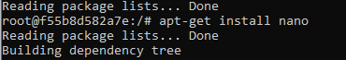

* + - 1. Get into the home folder and create a simple text file. Write a couple of lines in the text file such as your name.

* 1. Now that we have several images. Let’s delete the busybox image.

* 1. Delete all containers that have a status of exited.

1. Cleaning Up
   1. We have containers and images that won’t be used anymore. They occupy space therefore let’s find them and delete them

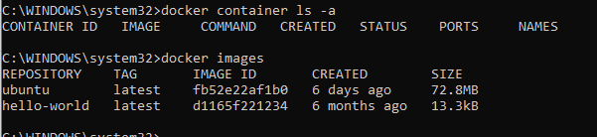

* 1. Find all images

* 1. Delete all images and containers that you won’t need anymore.

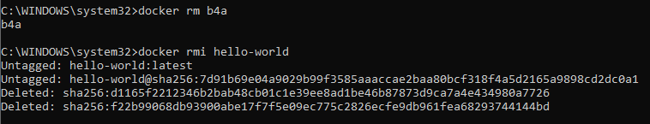

* 1. Submit the output for docker ps -a and docker images

1. Create an account in Docker Hub and browse for interesting images. List some that could be useful for you.

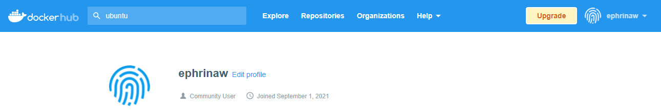

Some useful images:

* Ubuntu
* Mysql
* Maiadb
* Wordpress
* Django
* Apach
* Tomcat
* Joomla
* Ruby on Rails

# 